
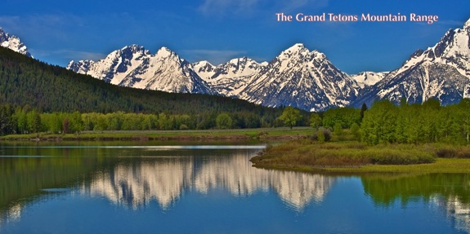
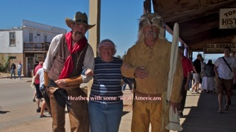
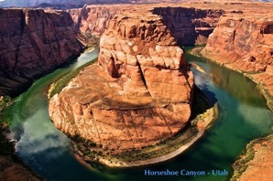
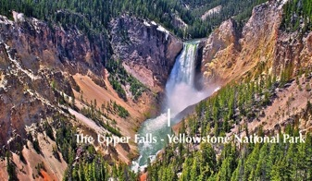
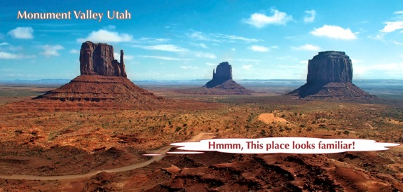
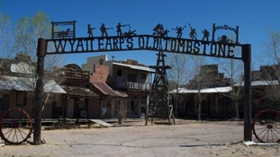
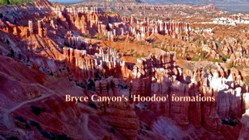




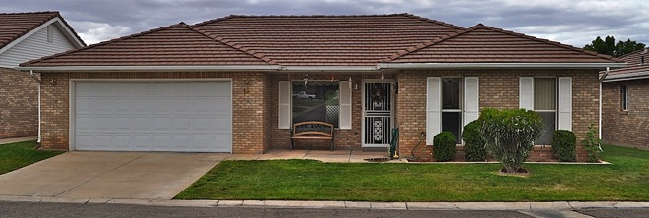
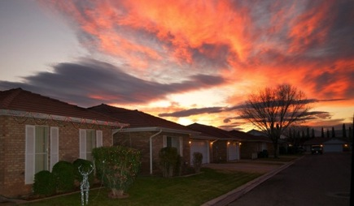
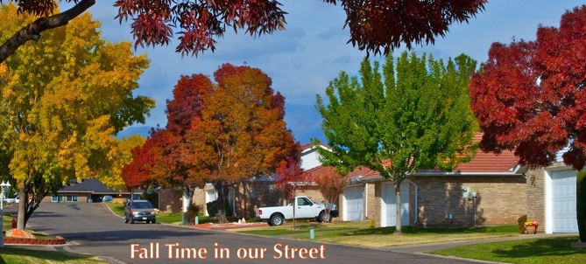
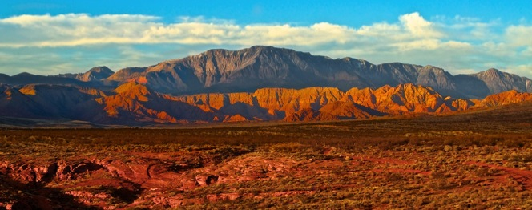
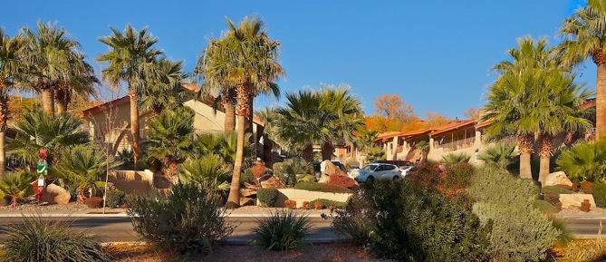
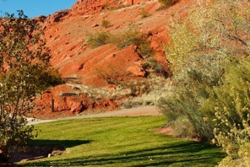
In our first year in the USA we travelled more than 12,000 miles across ten states on the western side of the country. Fanning out from our son and daughter-in-law’s home in Colorado, we visited major National Parks and forests, climbed snow covered mountains and camped by rivers and lakes.
Newsletter
Tom and Heather in America (website : www.whippsblog.com)
Old habits are hard to shake off – especially at this time of the year at Christmas, and although the tropical Queensland climate has been replaced (for us) by a mild northern hemisphere winter, home in Australia is still home. At a time when we think of real, and long term friends, past Christmas memories come back to question why we moved and, are we happy here? This isn’t to say we have any regrets because we are really enjoying our new life.
We continually thank God for the many blessings He has showered on our lives. Each day brings a new understanding of where we are today and how so many of our personal decisions have nestled us into such an incredible comfort zone.

Within those few states, we started to develop some preferences and southern Utah started to shine for us. In that state we visited Zion National Park several times and fell in love with Monument Valley of ‘so many movies’ fame and also The Grand Canyon and Yellowstone National Park……wild and beautiful places to be sure.

We visited ghost towns from the old west. Museums, historic towns, big cities and tiny towns littered our particular pathway through this incredibly diverse country.
The previous owners had meticulously maintained the internals with new carpets, new bathroom renovations, vertical blinds, plus ALL white goods in the kitchen and laundry.
A pretty amazing find, especially when the price was around a quarter of the price of a similar home in Brisbane. We moved in August, bought some nice furniture and began to shake off our wanderlust. Winter was not too far away!

During our travels, the town of St. George, in the southwestern corner of Utah, seemed to beckon us to go house hunting ! ! !
Houses all over the United States are, by Aussie standards, incredibly low priced! We found a 2 bedroom / 2 bathroom, detached brick house with tiled roof, covered patio and two car garage in a small 55+ walled community of 43 houses. Situated in a newer part of town with major shops, restaurants and a new hospital within walking distance and surrounded on all sides by mountain scenery.
The bright oranges, warm reds and gorgeous golds of our very special American Fall time (Autumn) are, all too briefly, upon us, tempting us with photographic opportunities at the turn of every corner. Such is the wild and natural, but short lived, beauty bestowed on this mountain valley town, by the regulatory behavior of the four seasons.
The mowing guys who descend upon our small estate, each Monday morning, stop at our entrance and survey the extra work the Fall has demanded of them. A million spent and crinkled leaves, scattered by the soft breezes, create a carpet of warm pastel colors beckoning the men’s broad leaf rakes to action. As they survey the picturesque landscape, the thought of this extra toil is softened by the less intense mowing regime that winter brings to the nearly dormant grass.

They tell us that if it snows in St George, it is usually melted away by lunchtime. We know that wherever you become acclimatized, summer is always hot and winter is still cold, but we think this town is one of America’s best-kept secrets.
With the onslaught of a mild northern hemisphere winter, our southern Utah temperatures are dropping, echoing a unity with the migratory habits of our human snowbirds, those members of our particular 76,000+ population who annually go south in search of warmer climes.

In a time gone by, the ‘fathers’ of this semi desert region, saw a need for its settlers to ‘green’ and beautify the arid landscape of this area which would become St George.
As with any desert region, water is a most valuable resource without which a town cannot survive and flourish.
The Virgin River, a sparkling streak of silver, glistens in the sunlight as its waters meander from the snow capped peaks around Zion Canyon, forty miles away, through several small towns, carrying its life preserving sustenance. The river continues on through St George, to much needed pastures and farmlands of lower altitudes.
This constant water supply has allowed for the installation of irrigation systems on every road and highway, throughout shopping centers, parks and domestic gardens.
An emerald swathe of green lawns and multicolored trees, populate the view across the landscape that is St George, in Utah.
The strong green colors of the parkland scenery augment the incredibly multicolored mountains and bluffs that are the backdrop to a landscape that attracts artists and photographers alike, to the town.
In any direction and at any time of the day the angle of the sun paints vivid pinks, reds and yellows as it draws the color out of the rich and varied sandstone.
The many walkways and hiking trails around this relatively new town, have some of their starting points at some place along the reaches of the Virgin River. The dog walkers, cyclists and the exercise conscious, have all been catered for on this two lane, mile marked bitumen expanse provided for by a forward thinking town council.

In so many areas, new buildings of all shapes, sizes and colors have sprung up, not crammed in by tight town planning control but utilizing the plentiful space and placing their own varying, but distinctive styles, onto the overall picture.

St George’s topography is also very special when viewed as part of a bigger picture that, on driving for between two and six hours, reaches Las Vegas and Reno, Los Angeles and San Diego, Salt Lake City, Phoenix and Tucson Arizona, all towns immortalized by song writers of our recent past. We have been briefly to them all and plan to visit again on a less intense schedule that will allow us to stop and smell the roses!

So this is home for the foreseeable future…. comfortable, inexpensive and beautiful!
We never thought retirement would be like this!

~~~~~~~~~~~~~~~~~~~~~~~~~~

So, to all our friends, we wish you a happy Christmas and a joyful and successful New Year. We are really sorry we can’t be with you, but you are in our thoughts and prayers…God Bless You all.
Tom and Heather.
~~~~~~~~~~~~~~~~~~~~~~~~~~
PS. If you would like to read more of our adventures in America, please click on our website http://www.whippsblog.com . There are pictures, stories and videos.

